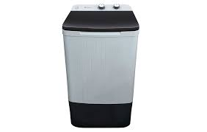

DW 6100 C

* Single Washer Household
* Warranty 1 Years
* Deep Water Fall Technology
* Wide Impeller
* **Rs.15,600**